- Create a string containing an integer, then convert that string into an actual integer object using int(). Test that your new object is a number by multiplying it by another number and displaying the result.
Input
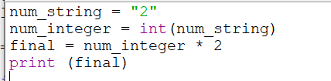

Output
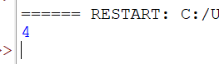

- Repeat the previous exercise, but use a floating-point number and float()
Input:
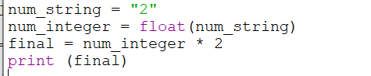

Output
